Project Design Phase
Solution Architecture

Date | 30 june 2026
Team ID | SB_2026_NutriAssist_01
Project Name | NutriAssist — Personalized Nutrition Assistant
Maximum Marks | 4 Marks

Solution Architecture:
Solution architecture is a complex process – with many sub-processes – that bridges the gap between business problems and technology solutions. Its goals are to:
- Find the best tech solution to solve existing business problems.
- Describe the structure, characteristics, behavior, and other aspects of the software to project stakeholders.
- Define features, development phases, and solution requirements.
- Provide specifications according to which the solution is defined, managed, and delivered.

NutriAssist Solution Architecture Diagram:

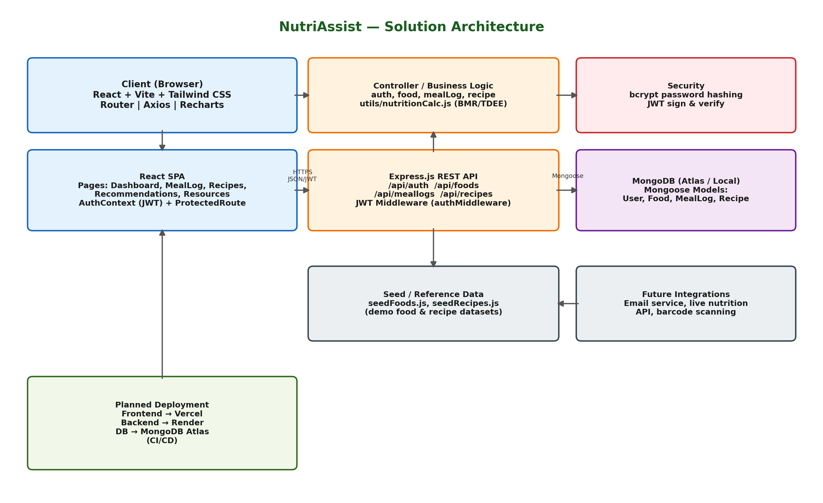
Figure 1: NutriAssist end-to-end architecture — React client, Express REST API, and MongoDB data layer
Description: The React client (browser) sends authenticated HTTPS/JSON requests through Axios to the Express REST API. Express routes attach JWT auth middleware, then hand off to controllers that hold the business logic, including BMR/TDEE/macro calculations. Controllers read and write data through Mongoose models to MongoDB (User, Food, MealLog, Recipe collections). Passwords are hashed with bcrypt and sessions are stateless, secured by signed JWTs. Reference/seed data populates the Food and Recipe collections for local development, and the app is designed to be deployed with the frontend on Vercel, backend on Render, and database on MongoDB Atlas.

Architecture Components:
Layer | Technology | Responsibility
Client | React (Vite), Tailwind CSS, React Router, Axios, Recharts, lucide-react | Renders pages (Dashboard, Meal Log, Recipes, Recommendations, Resources), manages auth state via AuthContext, and calls the API through a shared Axios instance carrying the JWT.
API / Application | Node.js, Express.js | Exposes REST routes (auth, foods, meallogs, recipes); authMiddleware verifies JWTs; controllers hold business logic, including BMR/TDEE/macro calculations in utils/nutritionCalc.js.
Data | MongoDB, Mongoose | Stores User, Food, MealLog, and Recipe documents; seed scripts (seedFoods.js, seedRecipes.js) populate reference data for development.
Security | bcrypt, JSON Web Tokens | Passwords hashed (bcrypt, 10 rounds) before storage; JWTs (7-day expiry) authenticate stateless requests and are validated on every protected route.
Deployment (planned) | Vercel, Render, MongoDB Atlas, CI/CD | Frontend hosted on Vercel, backend API on Render, database on MongoDB Atlas, with an automated build/deploy pipeline.

